Dataset (baseg)

You can just discard the variable X

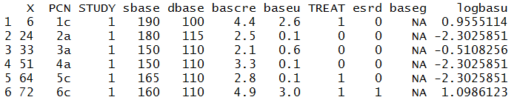

Predictive Plots example

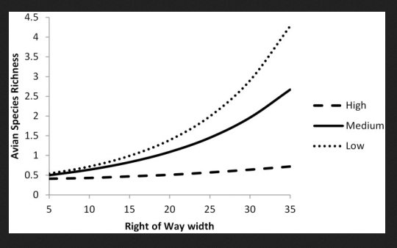

In this example the outcome variable is Avian Species Richness and the two Predictors are Right of Way width and Size (categorical—high, medium, low).

Above is a predictive plot of Right of Way width. They fit a model (Model 1) of Avian Species Richness explained by Right of Way width and Size. They predicted (using Model 1) on a dataset with a range of Right of Way width values and a fixed Size (low). They did the same: predicted (using Model 1) on a dataset with a range of Right of Way width values and a fixed Size (medium). And the did the same for using a fixed Size (high).

The general idea is that this is a predictive plot for Right of Way width because it looks at the predicted outcome (Avian Species Richness predicted using Model 1) for a range of values that Right of Way width can take on. However, the other predictors in the model must remain constant at a fixed value (eg Size = low).

You could also make a plot of Size (varying Low, Medium, High) and keeping Right of Way fixed. These plot are meant to give you an idea of how the outcome varies with the predictor.